Saurav Shrestha

Organocity

Customer (User) Testing

Organocity

# Table of Contents:

1. Registration
2. Login
3. Cart
4. User Details
5. Manage Cart
6. Checkout
7. Collection Slot
8. Email Verification
9. Search
10. Sign out

# Customer (User) Testing

1. Registration
   1. With empty fields

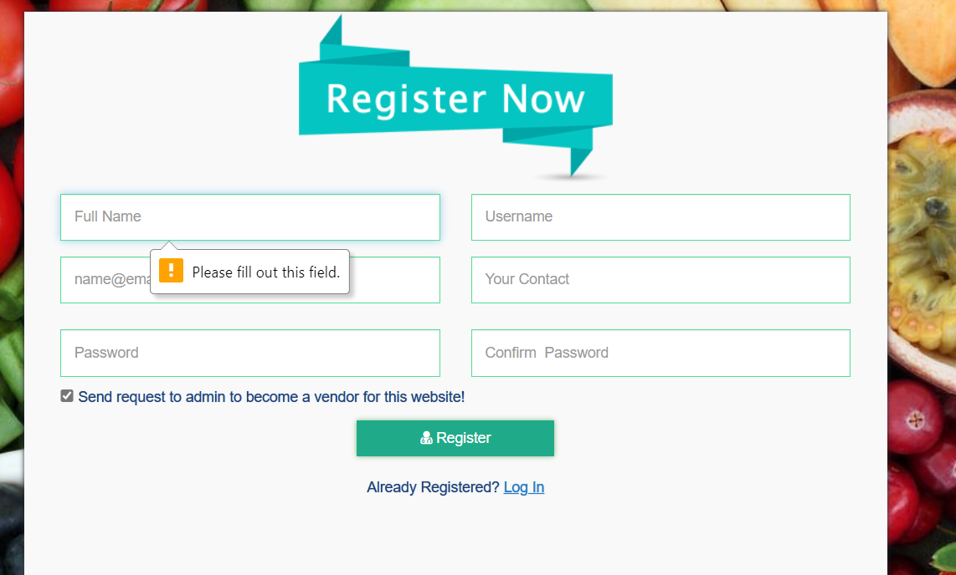

“Error Message”

* 1. With two field empty

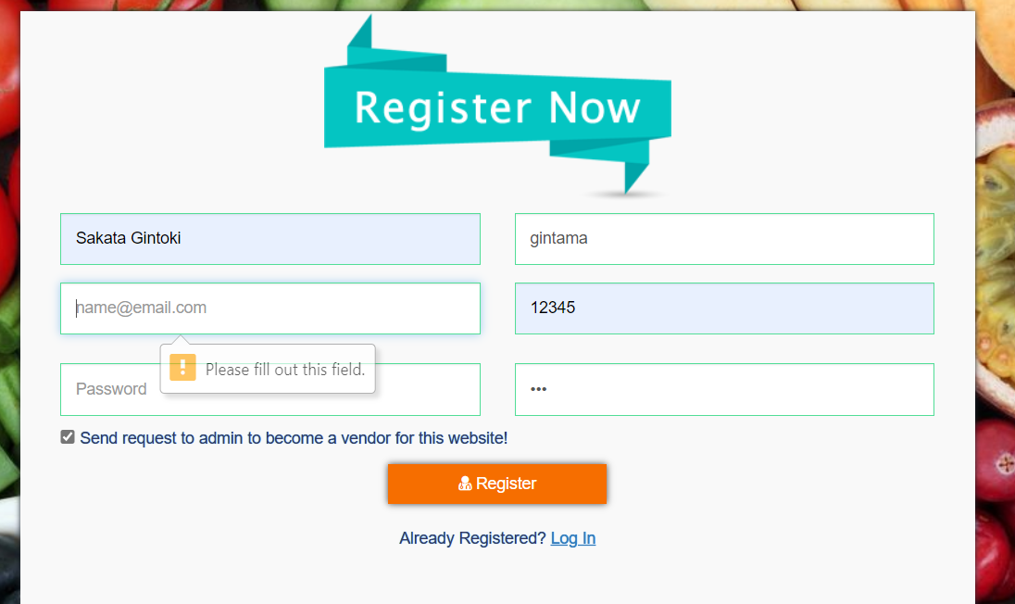

“Error Message”

* 1. With invalid fields

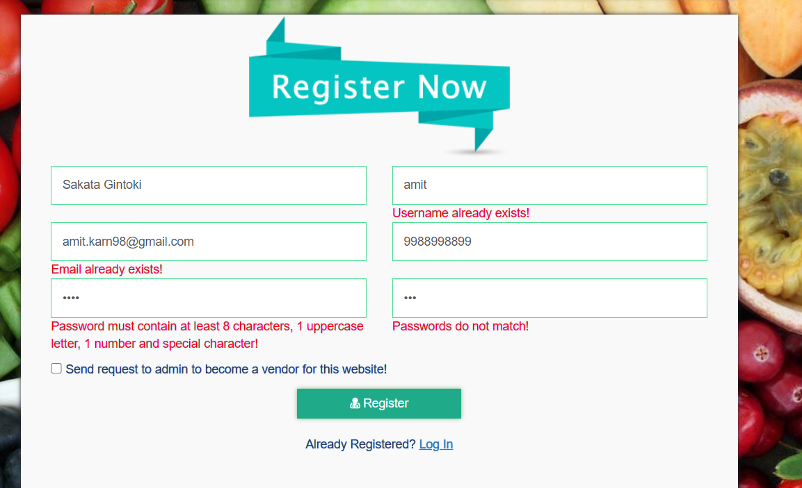

“Error Messages from server side”

* 1. With correct details

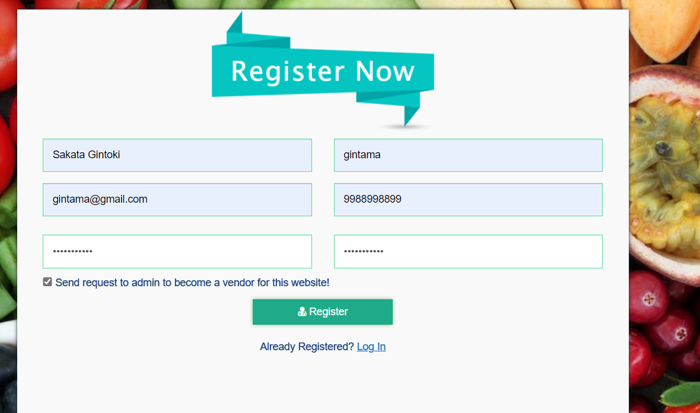

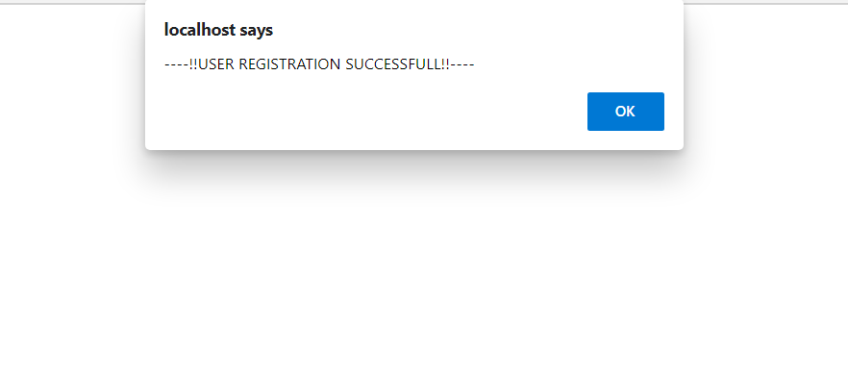

“Registration successful and redirected back to home page”

1. Login
   1. With empty fields

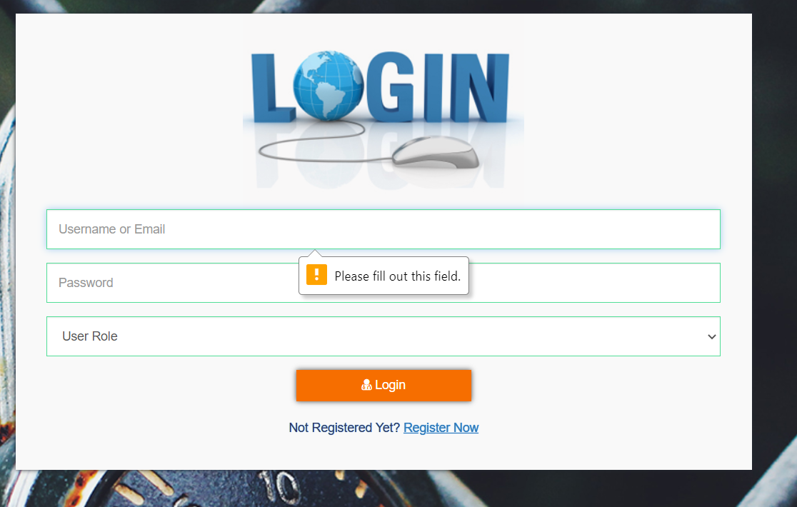

“Error message”

* 1. With invalid credentials

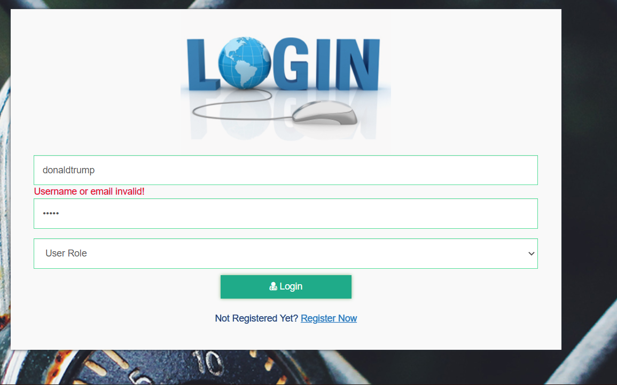

“Error message”

* 1. With Invalid role

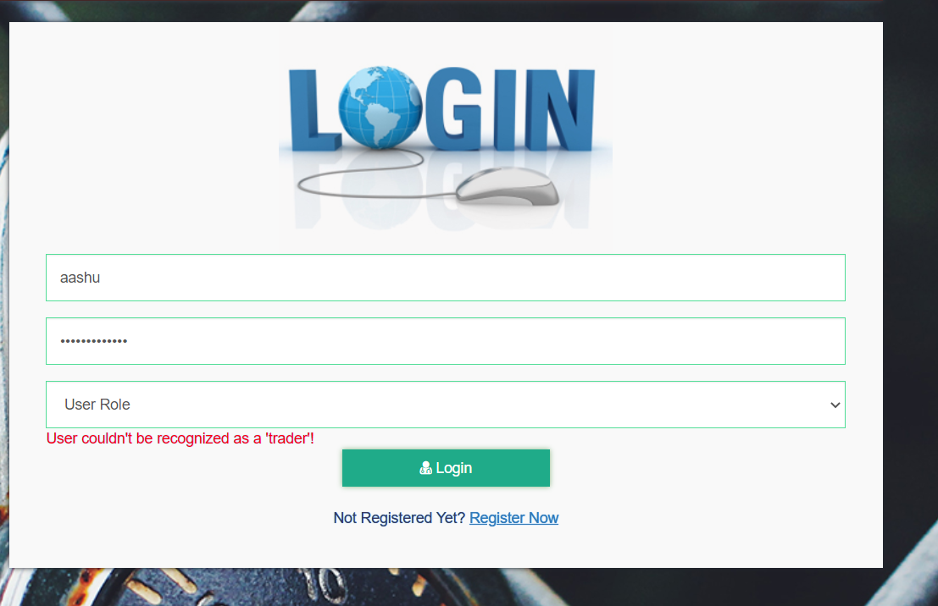

“Error Message”

* 1. With appropriate details

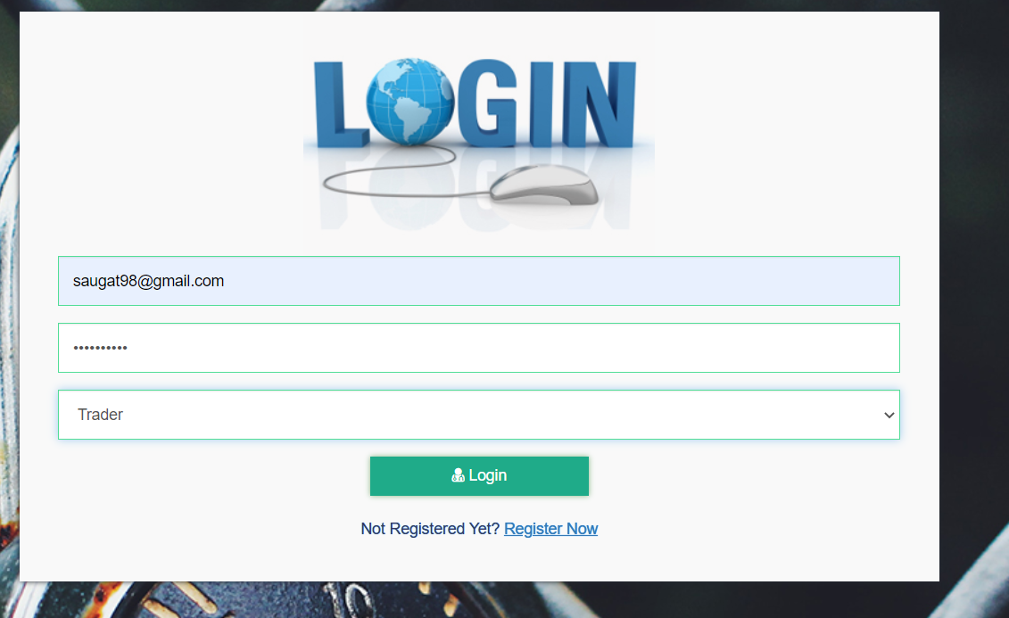

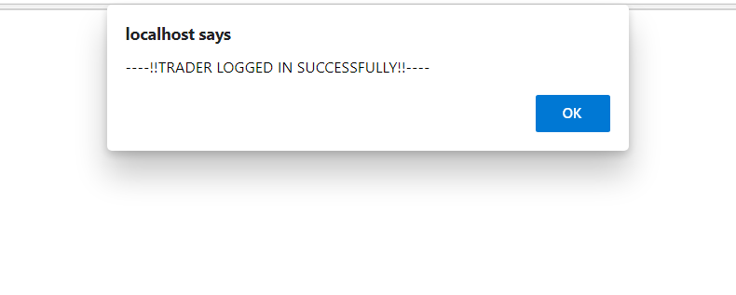

“Logs in and redirects to home screen”

1. Cart
   1. Adds item to cart without logging in

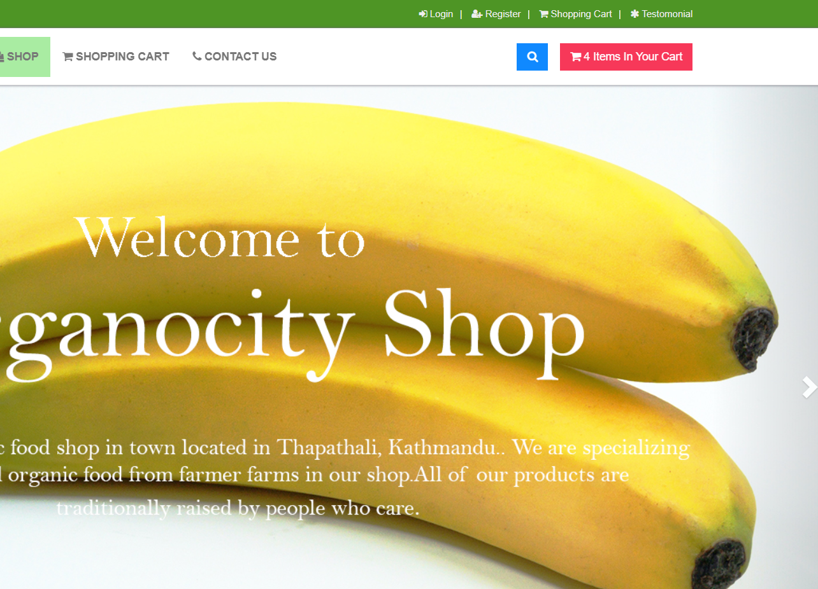

“Items get added to cart”

* 1. Restricts to access cart without login

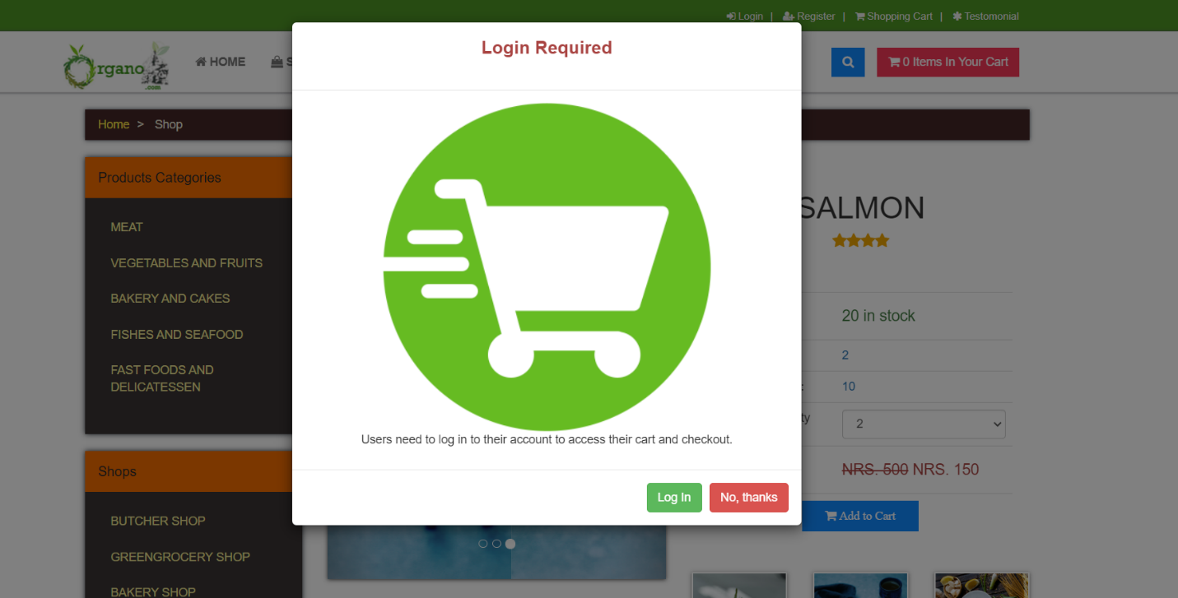

“Provides popup to log in before accessing cart”

1. User Details
   1. Change user details

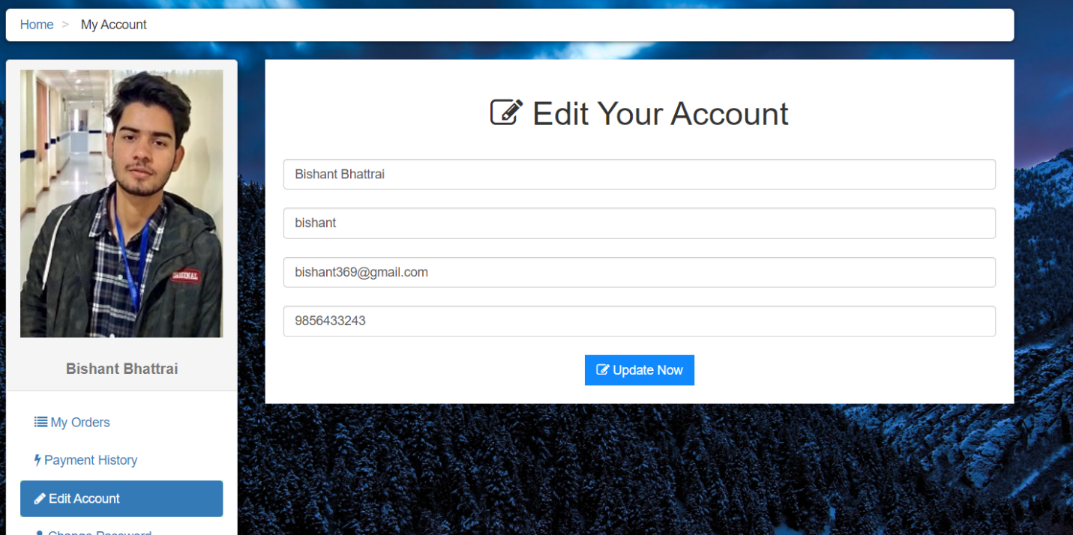

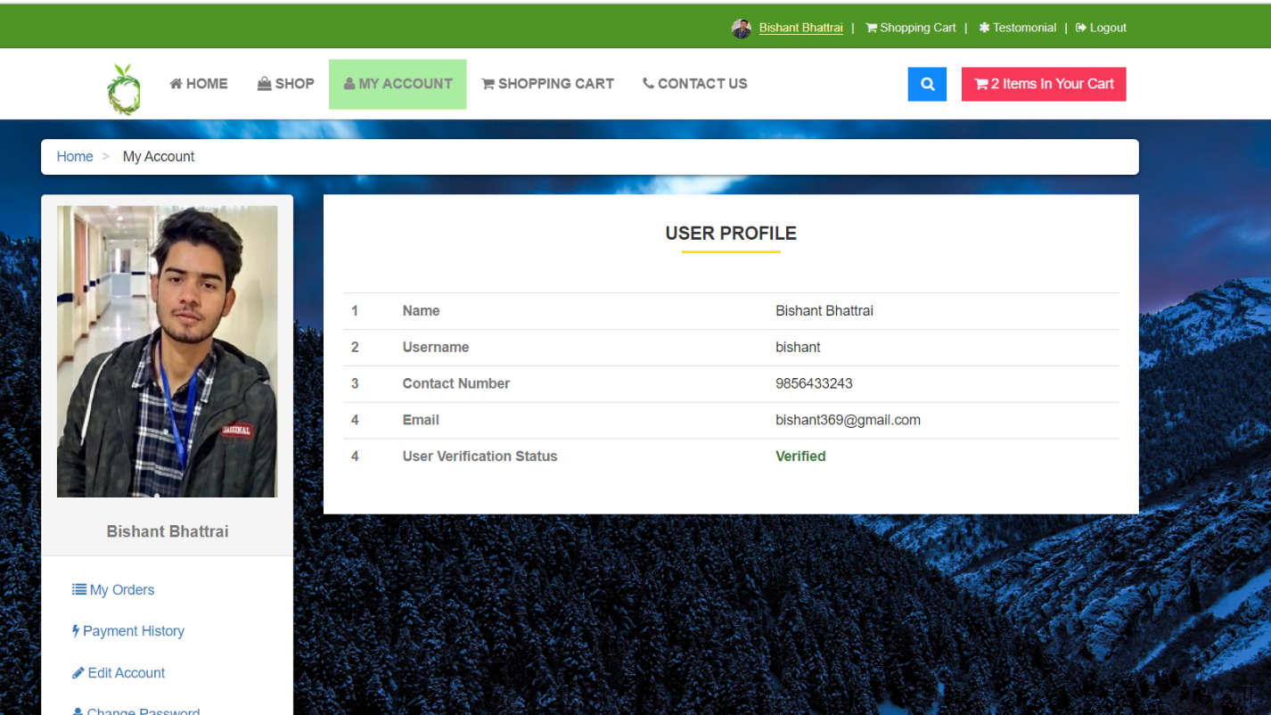

“User details change”

* 1. Change profile picture

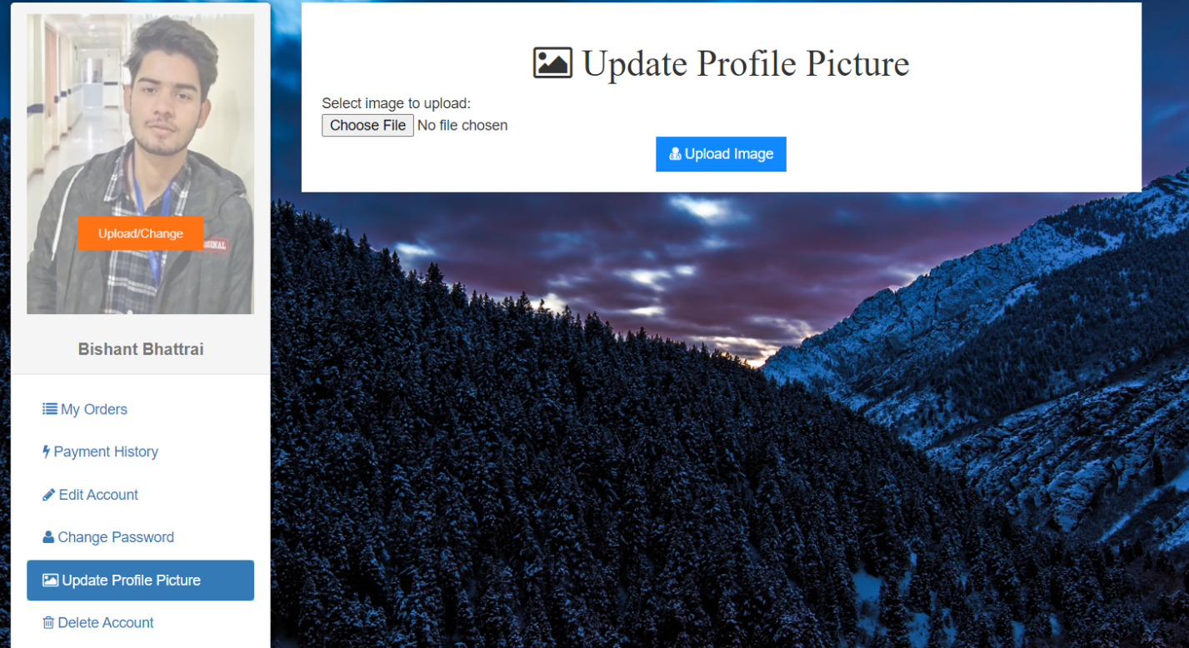

“Profile picture gets uploaded

* 1. Change Password

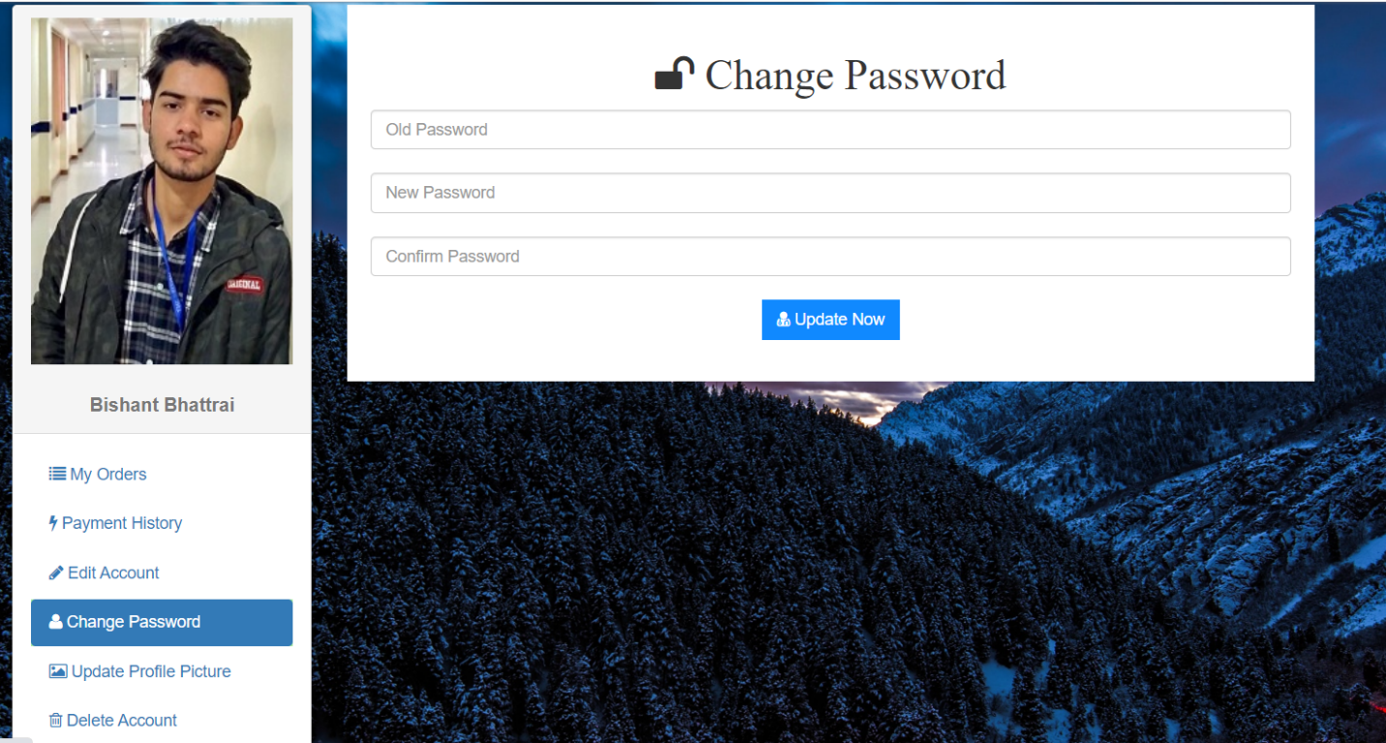

“Users passwords is changed”

1. Manage cart
   1. User removes products already in cart

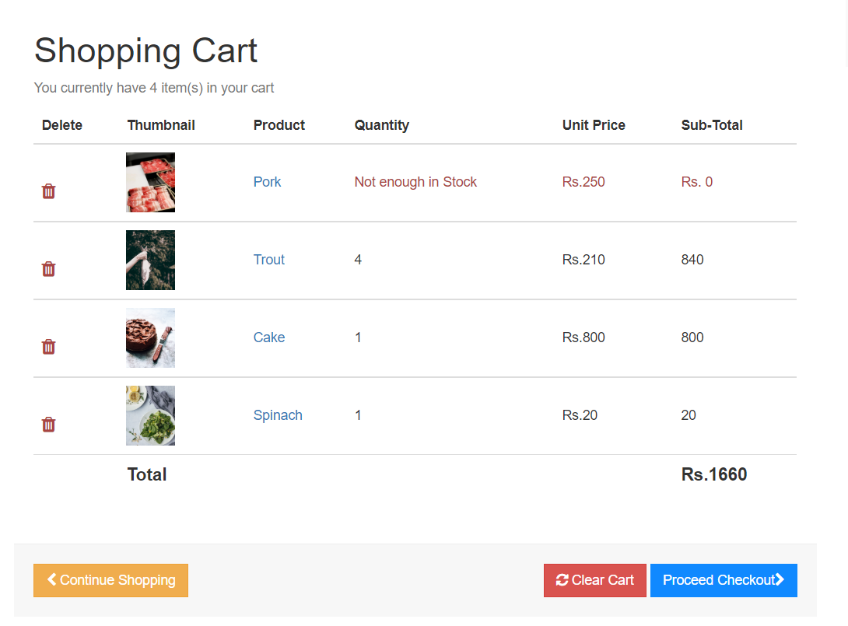

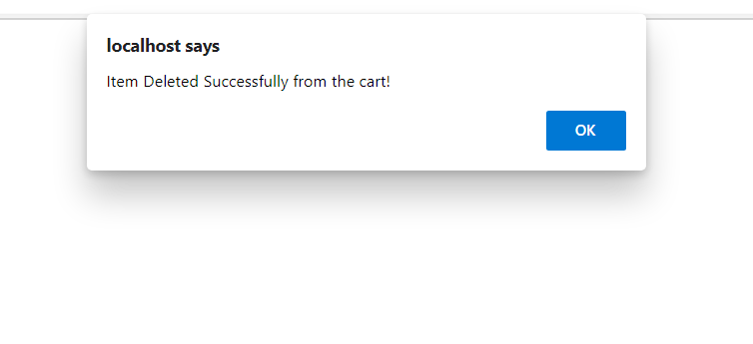

“Products in cart get removed”

* 1. Carts can be cleared

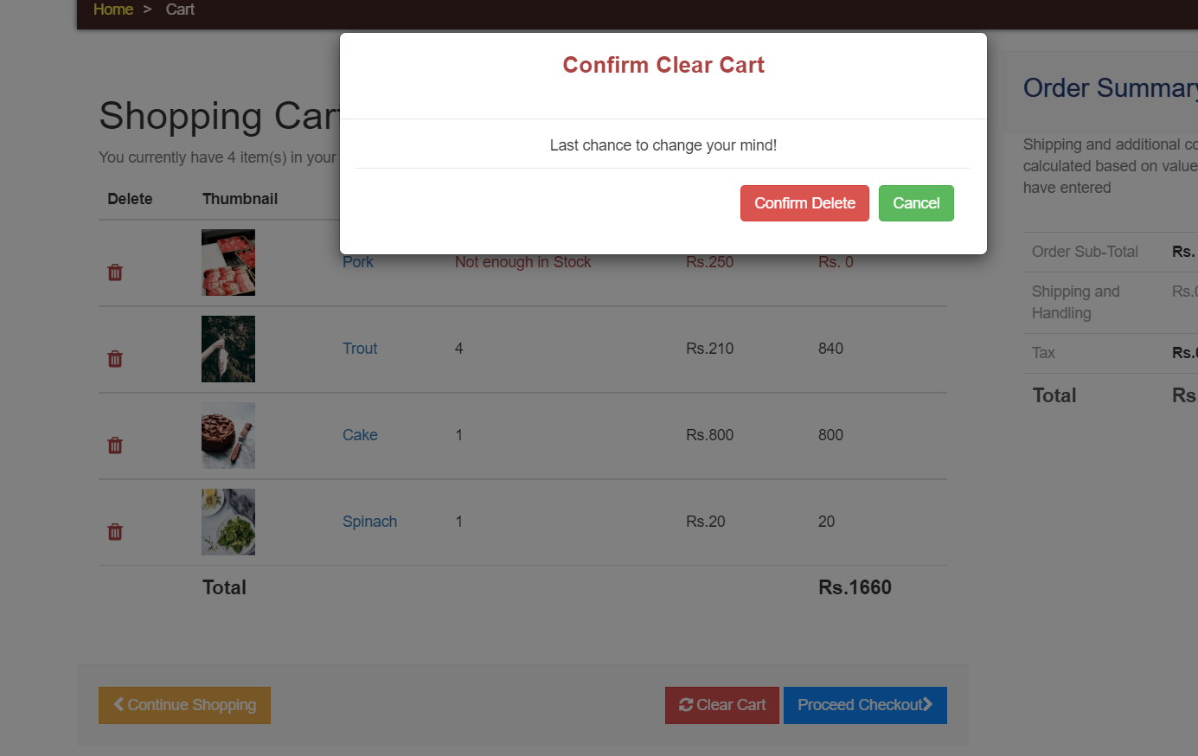

“All the products in the carts gets cleared at once”.

1. Checkout
   1. User pays with PayPal

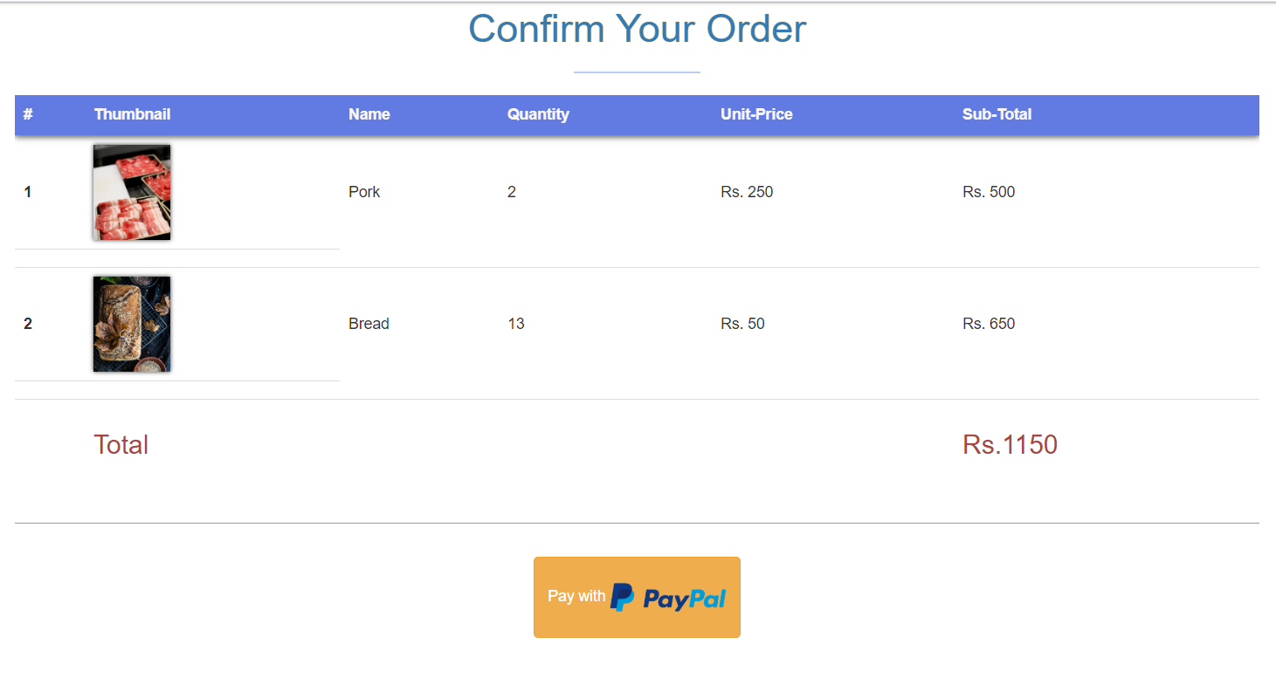

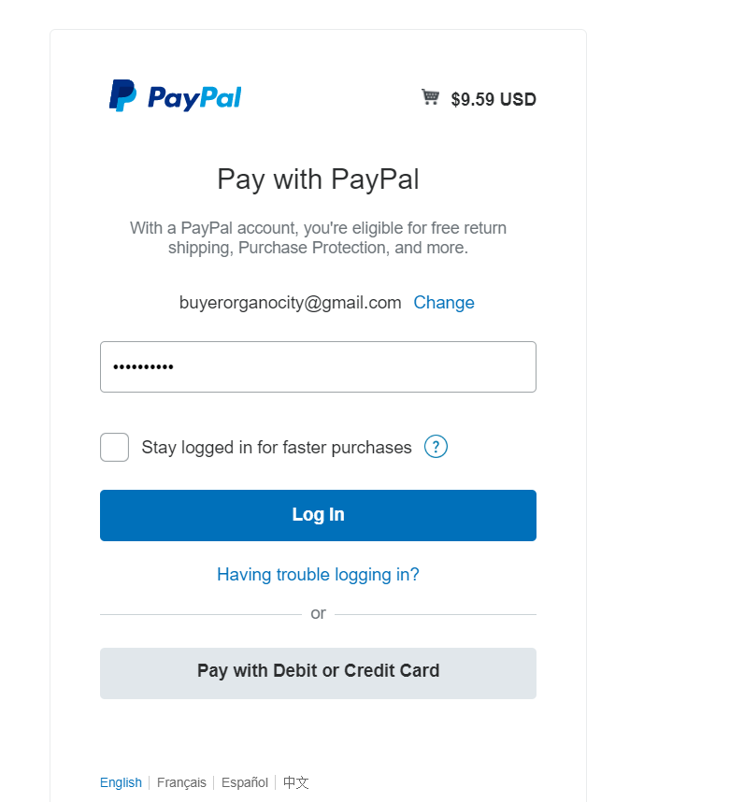

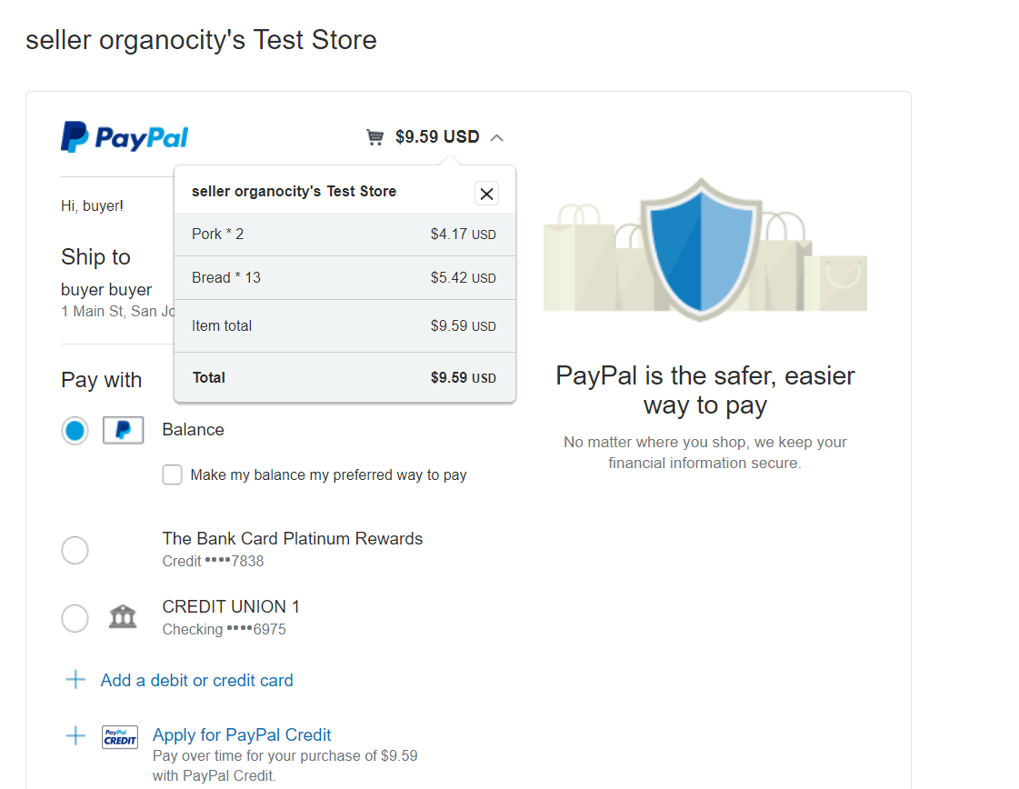

“Transaction approved and user is redirected to collection slot selection”

1. Collection Slot
   1. The slot selection dropdown only displays the available slot with dates and times

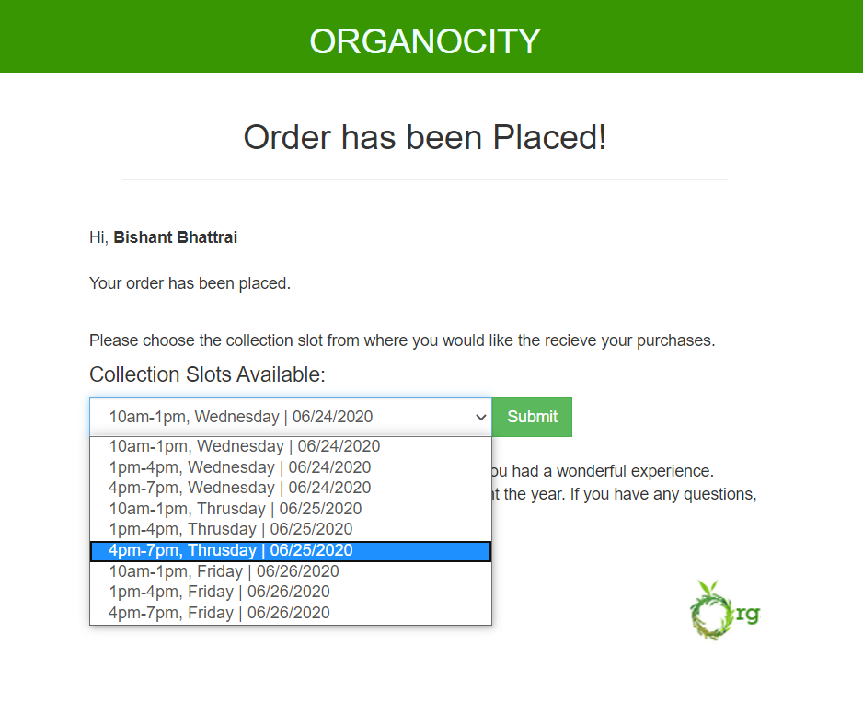

“Unavailable slots are disabled to select”

* 1. User selects available collection slot

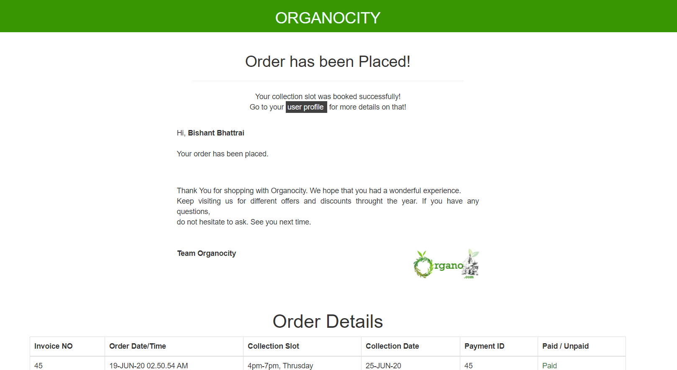

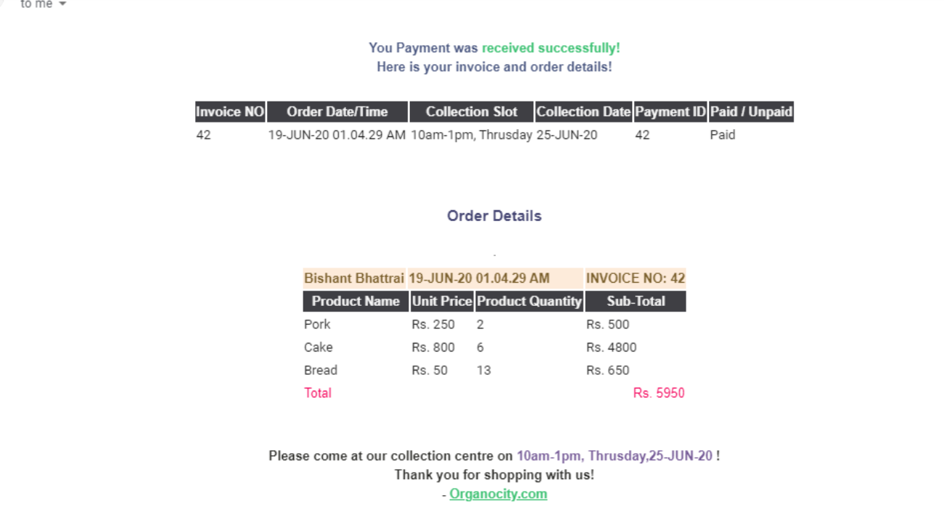

“Selection is approved, and receipt is sent to user via email”

1. Email Verification
   1. Every newly registered user is required to activate their account first via email verification

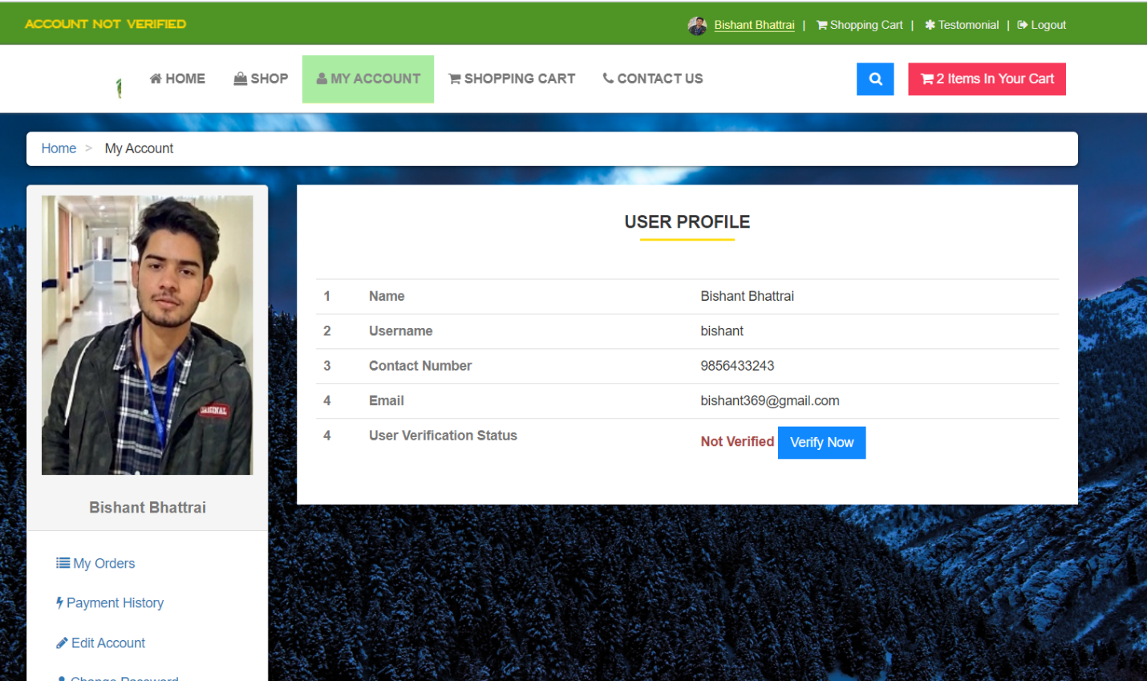

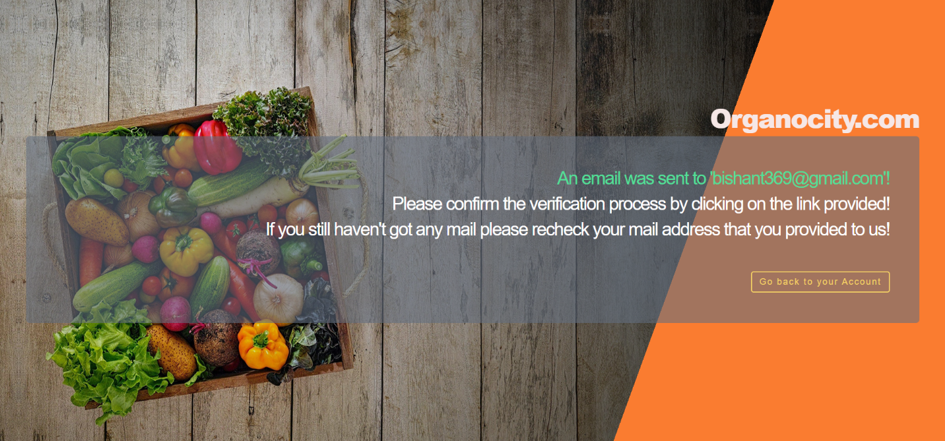

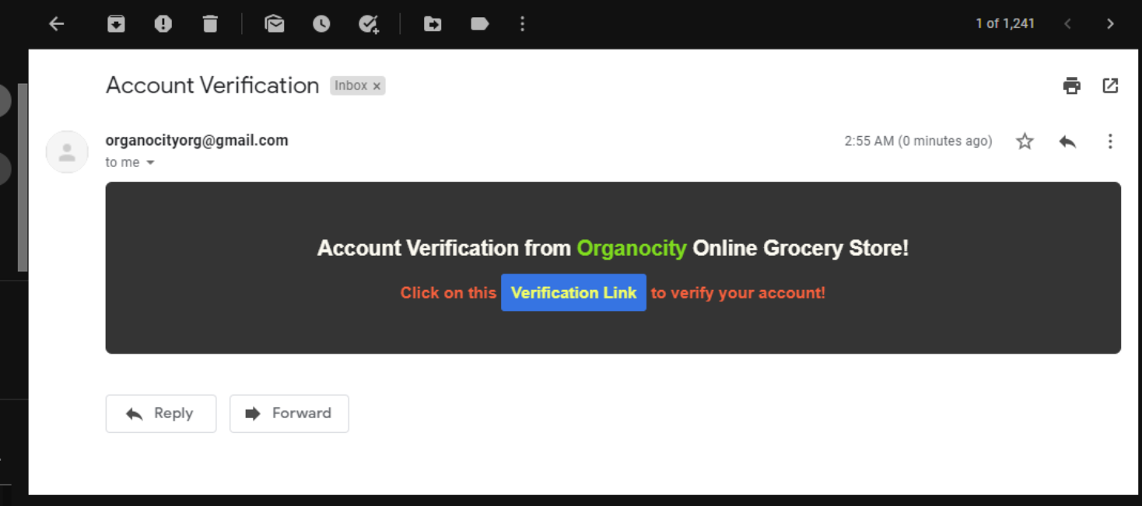



“Email verification link is sent to the user’s email”

* 1. Users cannot checkout without activating the account

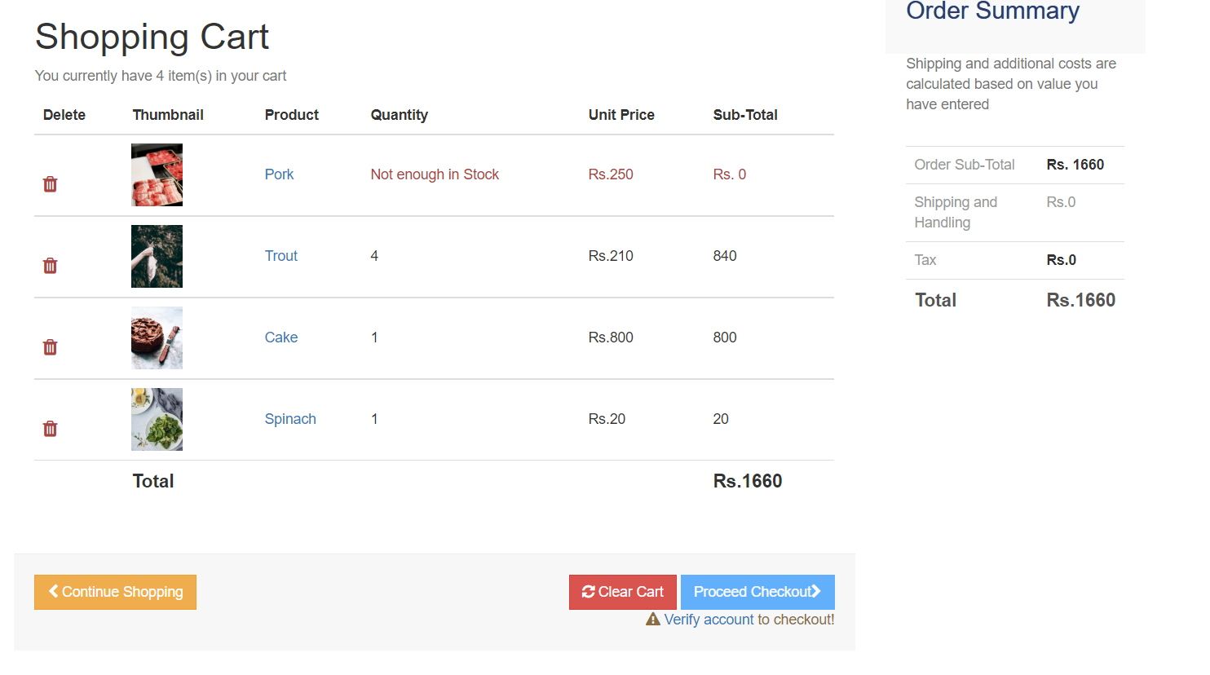

“The checkout button is disabled for unverified users”

1. Search Bar
   1. A dynamic search bar that searches and display the desired result

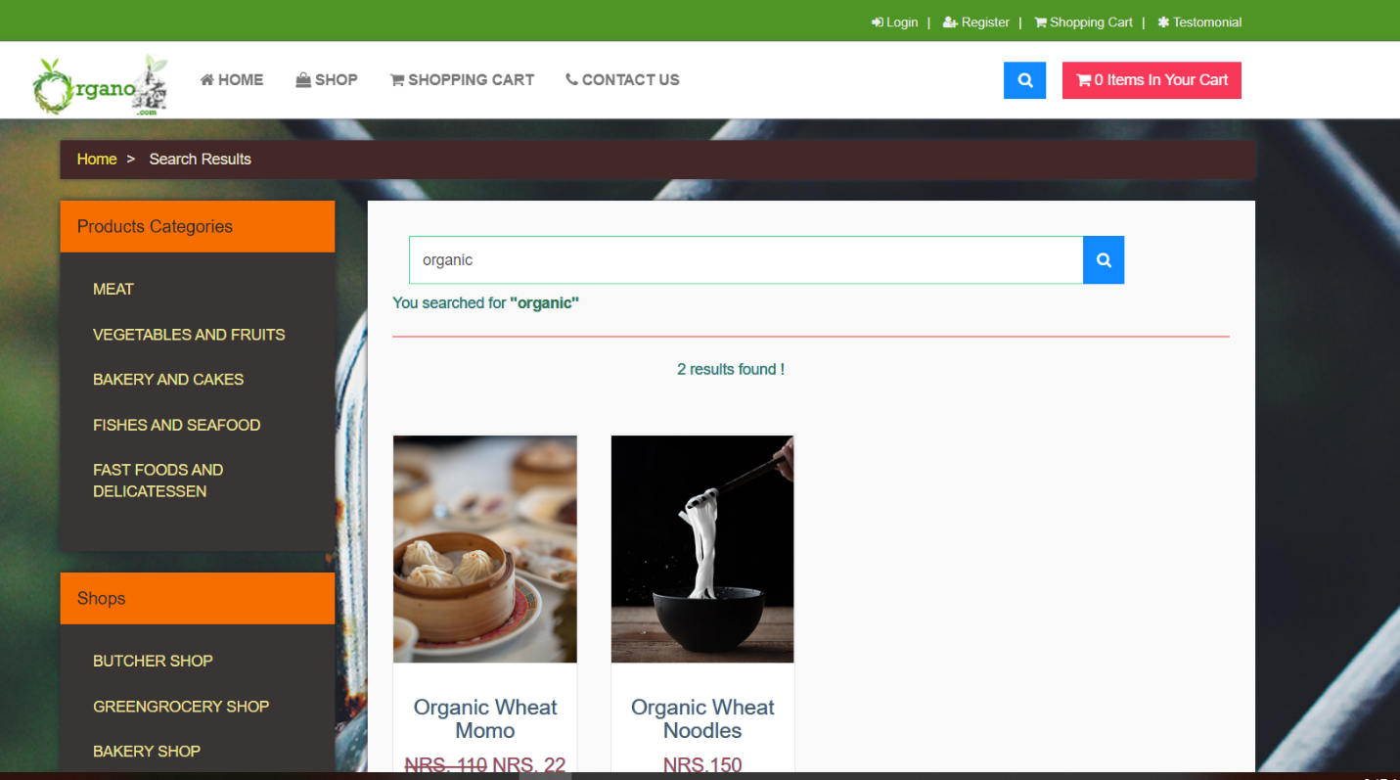

“The search results display the specific requests”

1. Sign out
   1. User signs out from the website

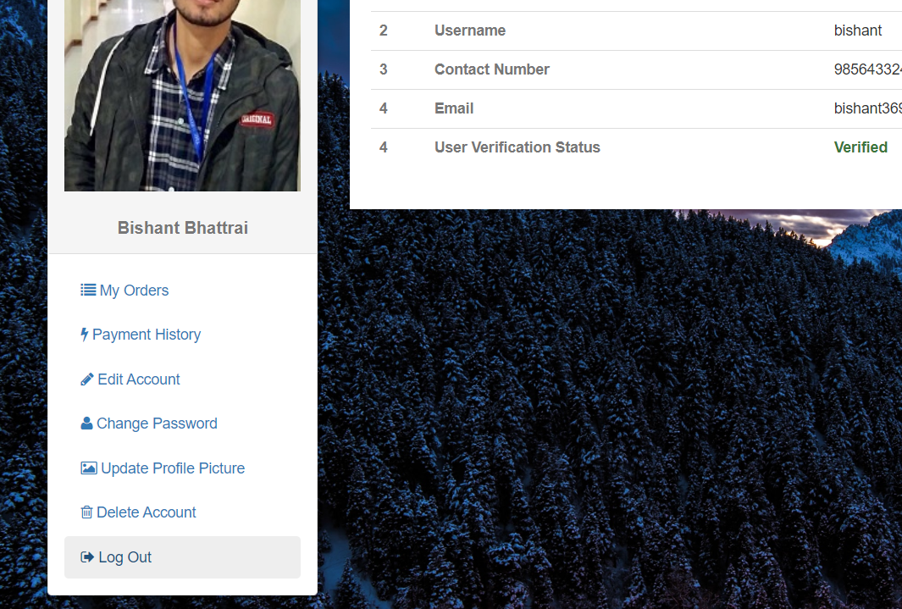

“Sign out is successful and redirected to homepage”